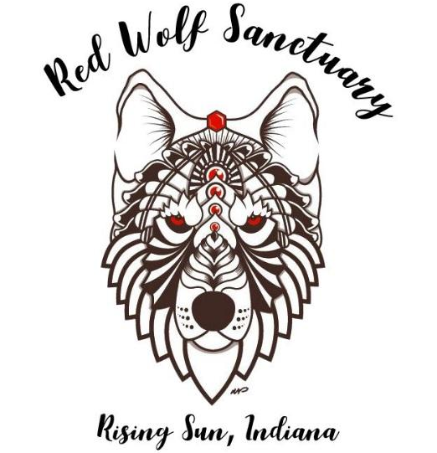
Name: _____________________________________
University: __________________________________
Major: _____________________________________
Email: _____________________________________
Cell Phone: ________________________________

Career Goals/Interests: ________________________________
_____________________________________________________
_____________________________________________________

Experience: __________________________________________
_____________________________________________________
_____________________________________________________

University Requirements for Internship (please list/explain the requirements specific to your school so we can best meet them): __________________________________________________________________
_____________________________________________________________________________________
_____________________________________________________________________________________

Availability: Summer:Weekdays 7am – 5pm, Saturdays 9am – 5pm
Winter: Weekdays 10am – 4pm, Saturdays 10am – 4pm
Date Available to start: __________________________________
Please fill out the weekly schedule below marking which day(s) you are available.
Monday | Tuesday | Wednesday | Thursday | Friday | Saturday

Interns/Volunteers will be required to help with all tasks as needed, even if it is outside of your interests. These tasks include animal husbandry, rehabilitation work, horticulture, enclosure construction and maintenance, meal preparation, cleaning, grounds keeping, education, etc.

Interns/volunteers must be able to lift 50 lbs, as well as stand and work for extended periods of time as needed. In addition, the intern/volunteer is regularly exposed to outside weather conditions.

All internships/volunteer positions are unpaid.
All interns and volunteers must be vaccinated for COVID-19 in order to be considered.

Don’t be discouraged from applying if you aren’t familiar with the tasks listed above, or don’t have any previous experience! We are a teaching facility with a goal of providing career experience through internships and volunteering. We are also committed to educating the public about conservation, ecology, and environmental science!

Applicants will be contacted shortly after their application is received.
The Red Wolf Sanctuary is in no way obligated to accept an intern/volunteer, even if this application is completed.

An Intern/Volunteer position may be terminated at any time at the Sanctuary’s discretion.

